505 HANDRAILS
505 Handrails
The 2010 Standards add a new technical requirement at section 406.3 for handrails along walking surfaces.
The 1991 Standards, at sections 4.8.5, 4.9.4, and 4.26, and the 2010 Standards, at section 505, contain technical requirements for handrails. The 2010 Standards provide more flexibility than the 1991 Standards as follows:
•Section 4.26.4 of the 1991 Standards requires handrail gripping surfaces to have edges with a minimum radius of 1/8 inch. Section 505.8 of the 2010 Standards requires handrail gripping surfaces to have rounded edges.
•Section 4.26.2 of the 1991 Standards requires handrail gripping surfaces to have a diameter of 1 ¼ inches to 1 1/2 inches, or to provide an equivalent gripping surface. Section 505.7 of the 2010 Standards requires handrail gripping surfaces with a circular cross section to have an outside diameter of 1 ¼ inches to 2 inches. Handrail gripping surfaces with a non-circular cross section must have a perimeter dimension of 4 inches to 6 ¼ inches, and a cross section dimension of 2 ¼ inches maximum.
•Sections 4.8.5 and 4.9.4 of the 1991 Standards require handrail gripping surfaces to be continuous, and to be uninterrupted by newel posts, other construction elements, or obstructions. Section 505.3 of the 2010 Standards sets technical requirements for continuity of gripping surfaces. Section 505.6 requires handrail gripping surfaces to be continuous along their length and not to be obstructed along their tops or sides. The bottoms of handrail gripping surfaces must not be obstructed for more than twenty percent (20%) of their length. Where provided, horizontal projections must occur at least 1 1/2 inches below the bottom of the handrail gripping surface. An exception permits the distance between the horizontal projections and the bottom of the gripping surface to be reduced by 1/8 inch for each 1/2 inch of additional handrail perimeter dimension that exceeds 4 inches.
•Section 4.9.4 of the 1991 Standards requires handrails at the bottom of stairs to continue to slope for a distance of the width of one tread beyond the bottom riser nosing and to further extend horizontally at least 12 inches. Section 505.10 of the 2010 Standards requires handrails at the bottom of stairs to extend at the slope of the stair flight for a horizontal distance at least equal to one tread depth beyond the last riser nosing. Section 4.1.6(3) of the 1991 Standards has a special technical provision for alterations to existing facilities that exempts handrails at the top and bottom of ramps and stairs from providing full extensions where it will be hazardous due to plan configuration. Section 505.10 of the 2010 Standards has a similar exception that applies in alterations.
A commenter noted that handrail extensions are currently required at the top and bottom of stairs, but the proposed regulations do not include this requirement, and urged the Department to retain the current requirement. Other commenters questioned the need for the extension at the bottom of stairs.
Sections 505.10.2 and 505.10.3 of the 2010 Standards require handrail extensions at both the top and bottom of a flight of stairs. The requirement in the 1991 Standards that handrails extend horizontally at least 12 inches beyond the width of one tread at the bottom of a stair was changed in the 2004 ADAAG by the Access Board in response to public comments. Existing horizontal handrail extensions that comply with 4.9.4(2) of the 1991 Standards should meet or exceed the requirements of the 2010 Standards.
Commenters noted that the 2010 Standards will require handrail gripping surfaces with a circular cross section to have an outside diameter of 2 inches, and that this requirement would impose a physical barrier to individuals with disabilities who need the handrail for stability and support while accessing stairs.
The requirement permits an outside diameter of 1 ¼ inches to 2 inches. This range allows flexibility in meeting the needs of individuals with disabilities and designers and architects. The Department is not aware of any data indicating that an outside diameter of 2 inches would pose any adverse impairment to use by individuals with disabilities.
Handrails Along Walkways. The 1991 Standards do not contain any technical requirement for handrails provided along walkways that are not ramps. Section 403.6 of the 2010 Standards specifies that where handrails are provided along walkways that are not ramps, they shall comply with certain technical requirements. The change is expected to have minimal impact.

505 Handrails
505.1 General. Handrails provided along walking surfaces complying with 403, required at ramps complying with 405, and required at stairs complying with 504 shall comply with 505.
Advisory 505.1 General. Handrails are required on ramp runs with a rise greater than 6 inches (150 mm) (see 405.8) and on certain stairways (see 504). Handrails are not required on walking surfaces with running slopes less than 1:20. However, handrails are required to comply with 505 when they are provided on walking surfaces with running slopes less than 1:20 (see 403.6). Sections 505.2, 505.3, and 505.10 do not apply to handrails provided on walking surfaces with running slopes less than 1:20 as these sections only reference requirements for ramps and stairs.
505.2 Where Required. Handrails shall be provided on both sides of stairs and ramps.
EXCEPTION: In assembly areas, handrails shall not be required on both sides of aisle ramps where a handrail is provided at either side or within the aisle width.
505.3 Continuity. Handrails shall be continuous within the full length of each stair flight or ramp run. Inside handrails on switchback or dogleg stairs and ramps shall be continuous between flights or runs.
EXCEPTION: In assembly areas, handrails on ramps shall not be required to be continuous in aisles serving seating.
505.4 Height. Top of gripping surfaces of handrails shall be 34 inches (865 mm) minimum and 38 inches (965 mm) maximum vertically above walking surfaces, stair nosings, and ramp surfaces. Handrails shall be at a consistent height above walking surfaces, stair nosings, and ramp surfaces.
Advisory 505.4 Height. The requirements for stair and ramp handrails in this document are for adults. When children are the principal users in a building or facility (e.g., elementary schools), a second set of handrails at an appropriate height can assist them and aid in preventing accidents. A maximum height of 28 inches (710 mm) measured to the top of the gripping surface from the ramp surface or stair nosing is recommended for handrails designed for children. Sufficient vertical clearance between upper and lower handrails, 9 inches (230 mm) minimum, should be provided to help prevent entrapment.
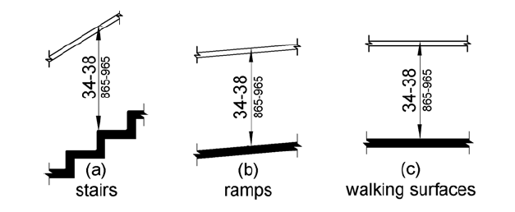
Figure 505.4 Handrail Height
505.5 Clearance. Clearance between handrail gripping surfaces and adjacent surfaces shall be 1 1/2 inches (38 mm) minimum.
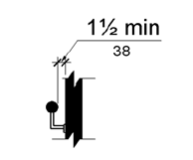
Figure 505.5 Handrail Clearance
505.6 Gripping Surface. Handrail gripping surfaces shall be continuous along their length and shall not be obstructed along their tops or sides. The bottoms of handrail gripping surfaces shall not be obstructed for more than 20 percent of their length. Where provided, horizontal projections shall occur 1 1/2 inches (38 mm) minimum below the bottom of the handrail gripping surface.
EXCEPTIONS:
1. Where handrails are provided along walking surfaces with slopes not steeper than 1:20, the bottoms of handrail gripping surfaces shall be permitted to be obstructed along their entire length where they are integral to crash rails or bumper guards.
2. The distance between horizontal projections and the bottom of the gripping surface shall be permitted to be reduced by 1/8 inch (3.2 mm) for each 1/2 inch (13 mm) of additional handrail perimeter dimension that exceeds 4 inches (100 mm).
Advisory 505.6 Gripping Surface. People with disabilities, older people, and others benefit from continuous gripping surfaces that permit users to reach the fingers outward or downward to grasp the handrail, particularly as the user senses a loss of equilibrium or begins to fall.
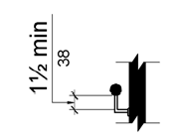
Figure 505.6 Horizontal Projections Below Gripping Surface
505.7 Cross Section. Handrail gripping surfaces shall have a cross section complying with 505.7.1 or 505.7.2.
505.7.1 Circular Cross Section. Handrail gripping surfaces with a circular cross section shall have an outside diameter of 1 1/4 inches (32 mm) minimum and 2 inches (51 mm) maximum.
505.7.2 Non-Circular Cross Sections. Handrail gripping surfaces with a non-circular cross section shall have a perimeter dimension of 4 inches (100 mm) minimum and 6 1/4 inches (160 mm) maximum, and a cross-section dimension of 2 1/4 inches (57 mm) maximum.
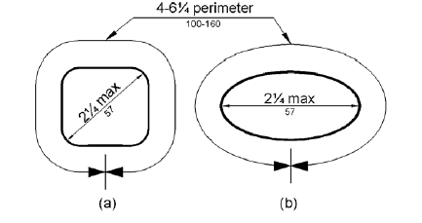
Figure 505.7.2 Handrail Non-Circular Cross Section
505.8 Surfaces. Handrail gripping surfaces and any surfaces adjacent to them shall be free of sharp or abrasive elements and shall have rounded edges.
505.9 Fittings. Handrails shall not rotate within their fittings.
505.10 Handrail Extensions. Handrail gripping surfaces shall extend beyond and in the same direction of stair flights and ramp runs in accordance with 505.10.
EXCEPTIONS:
1. Extensions shall not be required for continuous handrails at the inside turn of switchback or dogleg stairs and ramps.
2. In assembly areas, extensions shall not be required for ramp handrails in aisles serving seating where the handrails are discontinuous to provide access to seating and to permit crossovers within aisles.
3. In alterations, full extensions of handrails shall not be required where such extensions would be hazardous due to plan configuration.
505.10.1 Top and Bottom Extension at Ramps. Ramp handrails shall extend horizontally above the landing for 12 inches (305 mm) minimum beyond the top and bottom of ramp runs. Extensions shall return to a wall, guard, or the landing surface, or shall be continuous to the handrail of an adjacent ramp run.

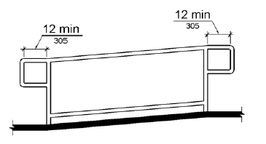
Figure 505.10.1 Top and Bottom Handrail Extension at Ramps
505.10.2 Top Extension at Stairs. At the top of a stair flight, handrails shall extend horizontally above the landing for 12 inches (305 mm) minimum beginning directly above the first riser nosing. Extensions shall return to a wall, guard, or the landing surface, or shall be continuous to the handrail of an adjacent stair flight.
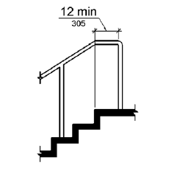
Figure 505.10.2 Top Handrail Extension at Stairs
505.10.3 Bottom Extension at Stairs. At the bottom of a stair flight, handrails shall extend at the slope of the stair flight for a horizontal distance at least equal to one tread depth beyond the last riser nosing. Extension shall return to a wall, guard, or the landing surface, or shall be continuous to the handrail of an adjacent stair flight.

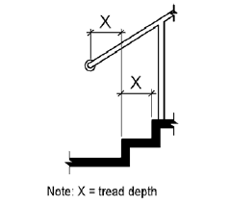
Figure 505.10.3 Bottom Handrail Extension at Stairs

