ADA RAMP

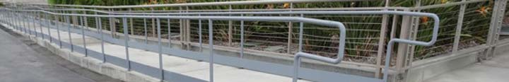

ADA Ramp

**4.8 Ramps**

**4.8.1* General**Any part of an accessible route with a slope greater than 1:20 shall be considered a ramp and shall comply with 4.8.

**4.8.2* Slope and Rise**The least possible slope shall be used for any ramp. The maximum slope of a ramp in new construction shall be 1:12. The maximum rise for any run shall be 30 in (760 mm). Curb ramps and ramps to be constructed on existing sites or in existing buildings or facilities may have slopes and rises as allowed in 4.1.6(3)(a) if space limitations prohibit the use of a 1:12 slope or less.

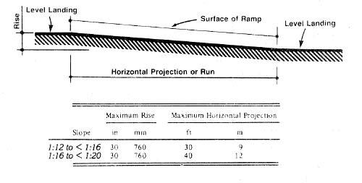

**4.8.3 Clear Width.**The minimum clear width of a ramp shall be 36 in (915 mm).

**4.8.4* Landings**Ramps shall have level landings at bottom and top of each ramp and each ramp run. Landings shall have the following features:

(1) The landing shall be at least as wide as the ramp run leading to it.  
(2) The landing length shall be a minimum of 60 in (1525 mm) clear.  
(3) If ramps change direction at landings, the minimum landing size shall be 60 in by 60 in (1525 mm by 1525 mm).  
(4) If a doorway is located at a landing, then the area in front of the doorway shall comply with 4.13.6.

**4.8.5* Handrails**If a ramp run has a rise greater than 6 in (150 mm) or a horizontal projection greater than 72 in (1830 mm), then it shall have handrails on both sides. Handrails are not required on curb ramps or adjacent to seating in assembly areas. Handrails shall comply with 4.26 and shall have the following features:

(1) Handrails shall be provided along both sides of ramp segments. The inside handrail on switchback or dogleg ramps shall always be continuous.  
(2) If handrails are not continuous, they shall extend at least 12 in (305 mm) beyond the top and bottom of the ramp segment and shall be parallel with the floor or ground surface.

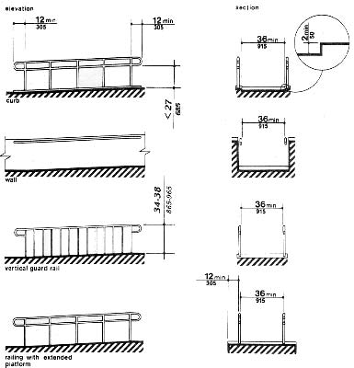

(3) The clear space between the handrail and the wall shall be 1 - 1/2 in (38 mm).  
(4) Gripping surfaces shall be continuous.  
(5) Top of handrail gripping surfaces shall be mounted between 34 in and 38 in (865 mm and 965 mm) above ramp surfaces.  
(6) Ends of handrails shall be either rounded or returned smoothly to floor, wall, or post.  
(7) Handrails shall not rotate within their fittings.

**4.8.6 Cross Slope and Surfaces**The cross slope of ramp surfaces shall be no greater than 1:50. Ramp surfaces shall comply with 4.5.

**4.8.7 Edge Protection**Ramps and landings with drop-offs shall have curbs, walls, railings, or projecting surfaces that prevent people from slipping off the ramp. Curbs shall be a minimum of 2 in (50 mm) high.

**Examples of Edge Protection and Handrail Extensions**

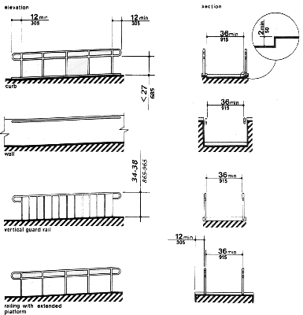

**Examples of Edge Protection and Handrail Extensions.**Four types of edge protection and handrail design are shown. The first ramp (top) labeled "Curb" shows a handrail horizontal projection of 12 inches (305 mm) minimum at the top and bottom of the ramp. The horizontal projection begins at the point were the sloped ramp surface stops. Edge protection on both sides of the ramp is a raised surface at least 2 inches (50 mm) high. A minimum clear width of 36 inches (915 mm) is provided between handrails and the edge protection. A lower railing is shown parallel to the ramp mounted no higher than 27 inches (685 mm) above the ramp.

The second ramp (second from top) labeled "Wall" shows a railing mounted on a solid wall. The handrails on both sides have horizontal projections as above. A minimum of 36 inches (915 mm) is provided between handrails.

The third ramp (third from top) labeled "Vertical Guard Rail" has a series of vertical guard rails or pickets. The top of the handrail is shown as 34 - 38 inches (865 mm - 965 mm) above the ramp and landings (applies to all handrails on accessible ramps). A minimum of 36 inches (915 mm) is provided between handrails.

The fourth ramp (fourth from top) labeled "Railing with Extended Platform" shows a railing without edge protection on the ramp surface. The ramp surface extends a minimum of 12 inches (305 mm) to the side of the handrail. The handrail detail is the same as the first example with a bottom rail no more than 27 inches (305 mm) above the ramp and landings. A minimum of 36 inches (915 mm) is provided between handrails.

**4.8.8 Outdoor Conditions**Outdoor ramps and their approaches shall be designed so that water will not accumulate on walking surfaces.

[Joom](http://www.joomace.net/joomla-extensions/acesef)